**INTRODUCTION**

E-commerce means using the Internet and the web for business transactions and/or commercial transactions, which typically involve the exchange of value (e.g., money) across organizational or individual boundaries in return for products and services.

I build this ecommerce platform which I believe is a solution to the problem the local products sellers are facing today, which is they products are not able to sell more and not able to reach to many population as they can.

The platform is specifically to only sell the local products which known as **made in Rwanda,**

**How will it works,** it is the online platform(website) which a customer should be able to access it anywhere and able to buy any local products he/she wants, a customer will have many options to choose the quality products because the platform will have a feature for a seller to access the platform and be able to add different products by himself, herself without any intervention of our staffs.

The shopInn(my ecommerce platform) will enable the local products to be reached at every time, everywhere by everyone. This will be possible because this platform will work 24/7, the staff will always be happy to support.

**TECHNOLOGIES**

Here are some different technologies we used:

**HTML:** Hypertext Markup Language is the standard markup language for documents designed to be displayed in a web browser.

**CSS**: Cascading Style Sheets is a style sheet language used for describing the presentation of a document written in a markup language such as HTML.

**Javascript:** JavaScript, often abbreviated as JS, is a programming language that conforms to the ECMAScript specification. JavaScript is high-level, often just-in-time compiled, and multi-paradigm. It has curly-bracket syntax, dynamic typing, prototype-based object-orientation, and first-class functions.

**PHP:**  is a server side scripting language that is embedded in HTML. It is **used** to manage dynamic content, databases, session tracking, even build entire e-commerce sites. It is integrated with a number of popular databases.

**SQL:** is a domain-specific language used in programming and designed for managing data held in a relational database management system, or for stream processing in a relational data stream management system.

**XAMPP:** is a free and open-source cross-platform web server solution stack package developed by Apache Friends, consisting mainly of the Apache HTTP Server, MariaDB database, and interpreters for scripts written in the PHP and Perl programming languages.

**HOMEPAGE**

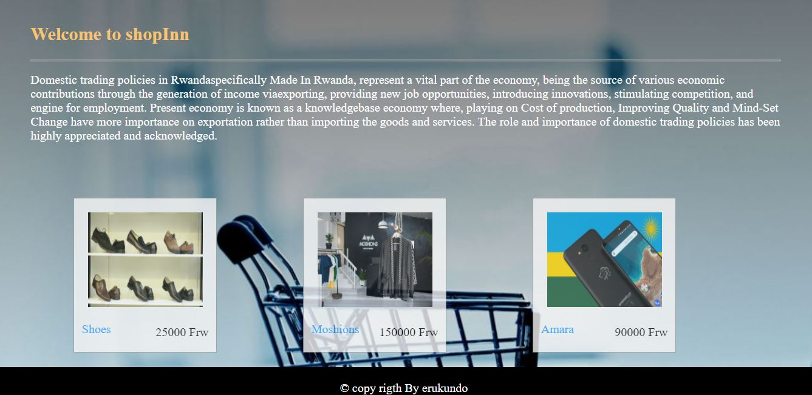

**Figure 1**

This is the landing page for our customer where the customer can be able to see the trending products, recent added products and can be able to click on the products to start the process of buying.

**The product details page**

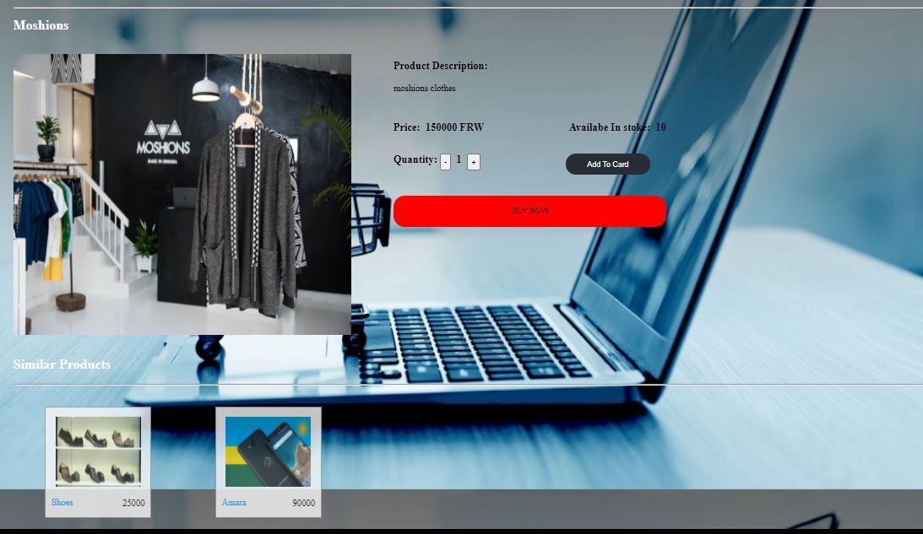

**FIGURE 2**

This page it displays the specific product details, from the page you are able to see the product name, price, quantity, descriptions and from on this page you can be able to buy the product right away or adding to you cart so that you can be able to buy it later.

**LOGIN PAGE**

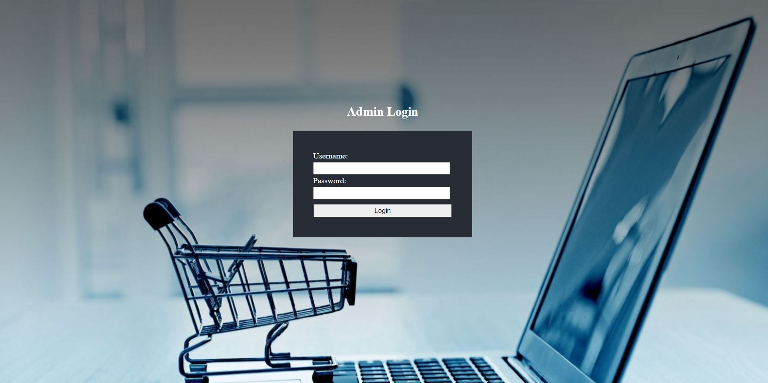

**FIGURE 3**

This is the admin login page, helps to secure the platform to be allow the authorized people (staffs) to access the dashboard which requires the correct username and password.

**DASHBOARD PAGE**

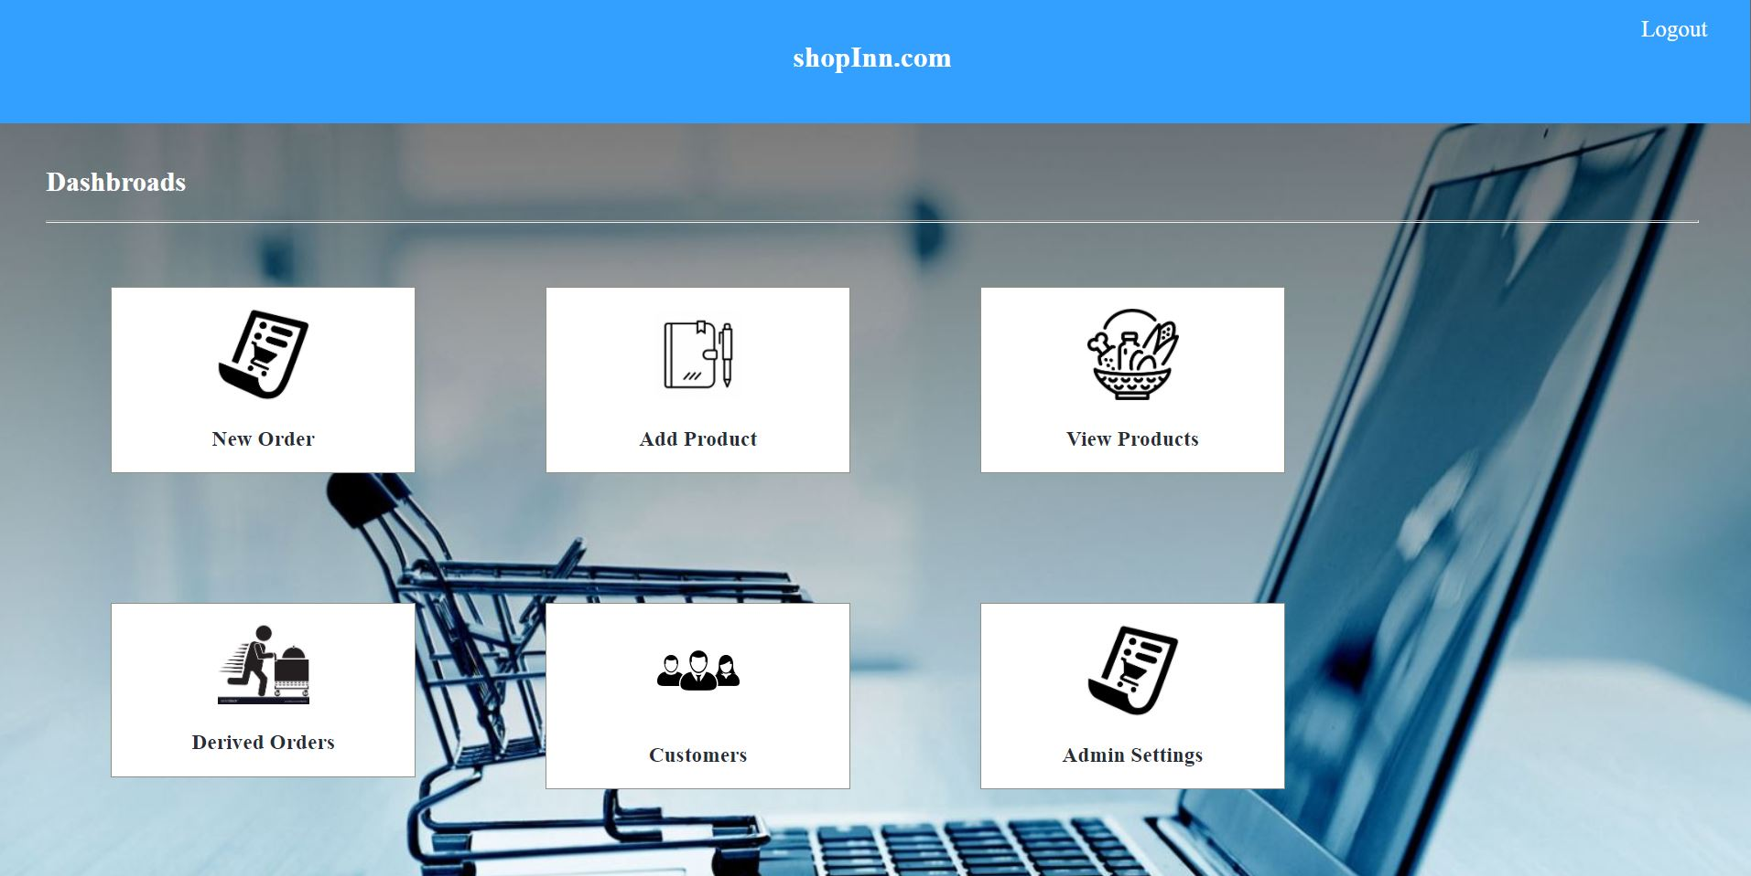

**FIGURE 4**

This is another crucial page that helps in managing the platform, it has different options you can be able to do on the web like New, add product, view products details, derived orders, customers and admin settings.

**NEW PRODUCT PAGE**

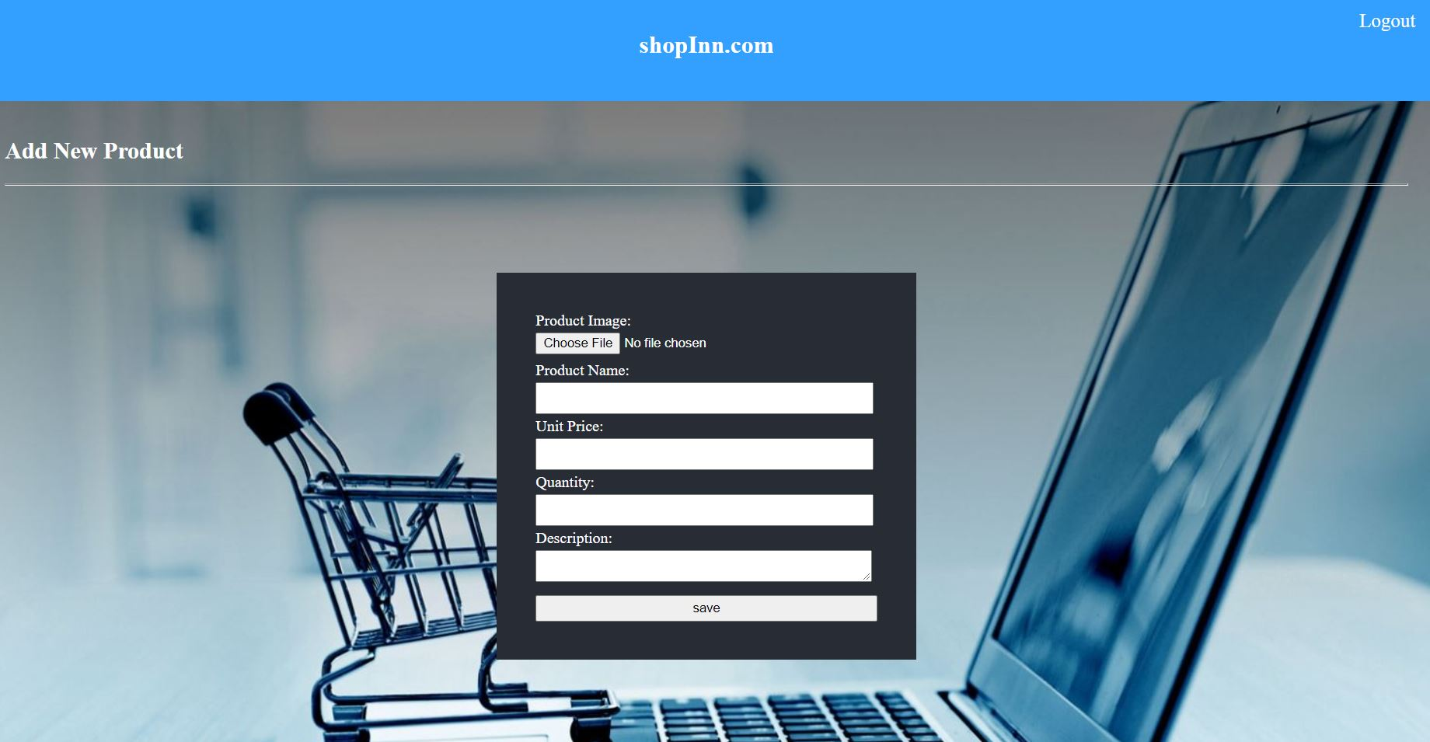

**FIGURE 5**

This is the crucial page on the platform, It is used on the adding a new product on the platform, and it is required and necessary to fill all the fields on the form.

**PRODUCT LIST**

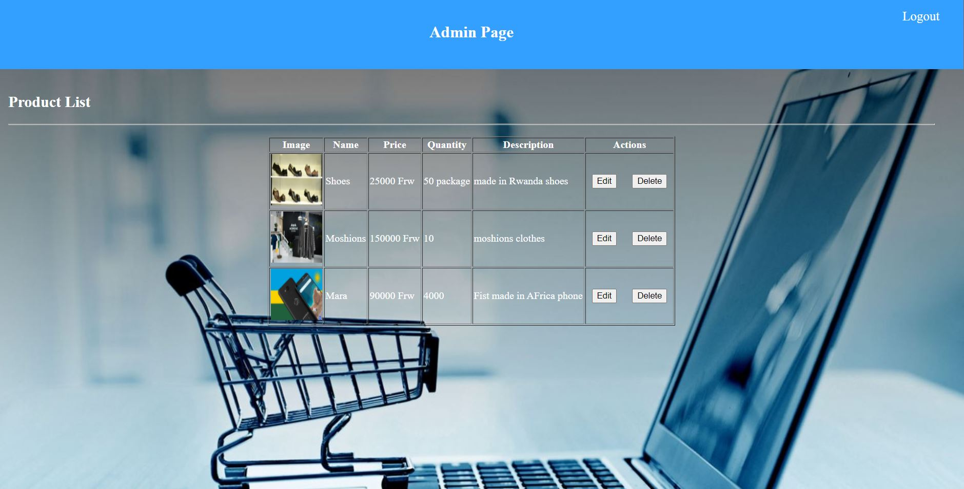

**FIGURE 6**

The product list page shows all the current products we have on the platform.

**EDIT PRODUCT DETAILS PAGE**

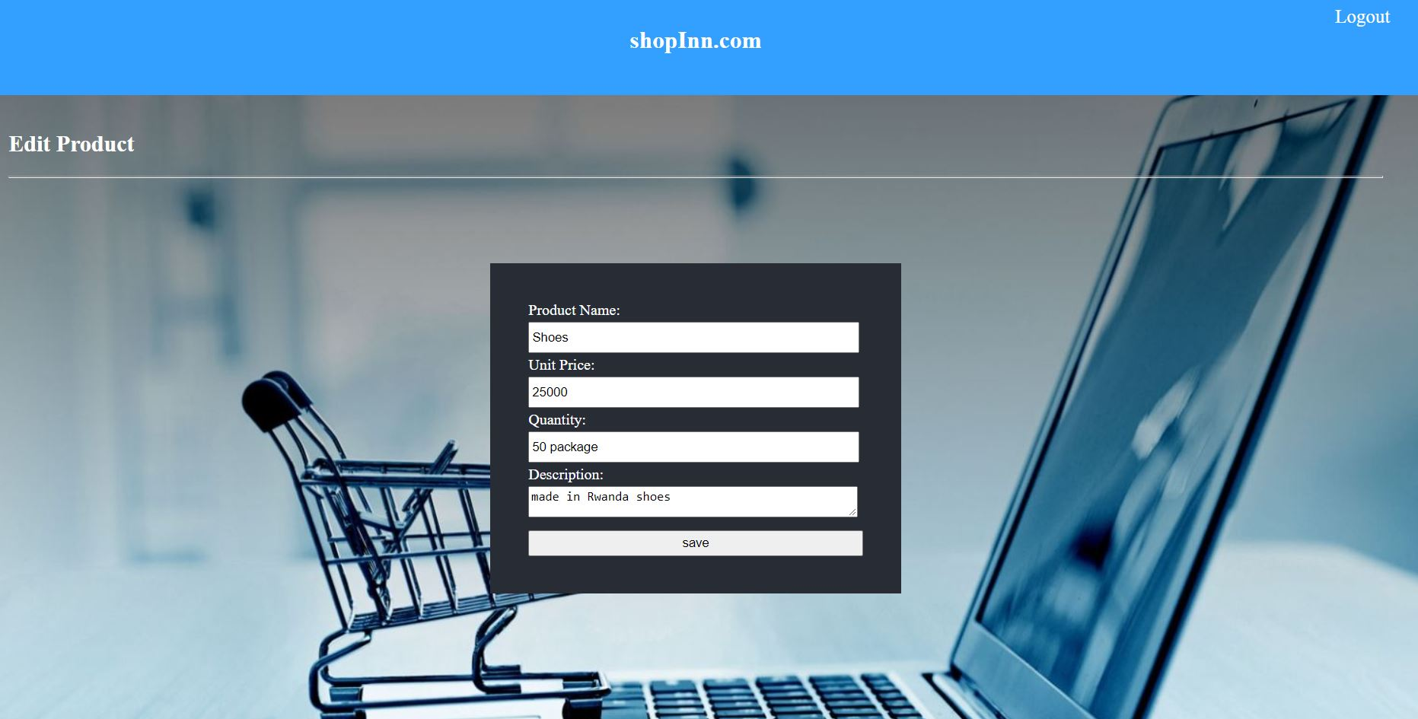

**FIGURE 7**

The edit product page helps in edit product details of the product we already have in our database. This is much needed the time you made a mistake while adding the product or you want to update the product details.

**Received Orders Page**

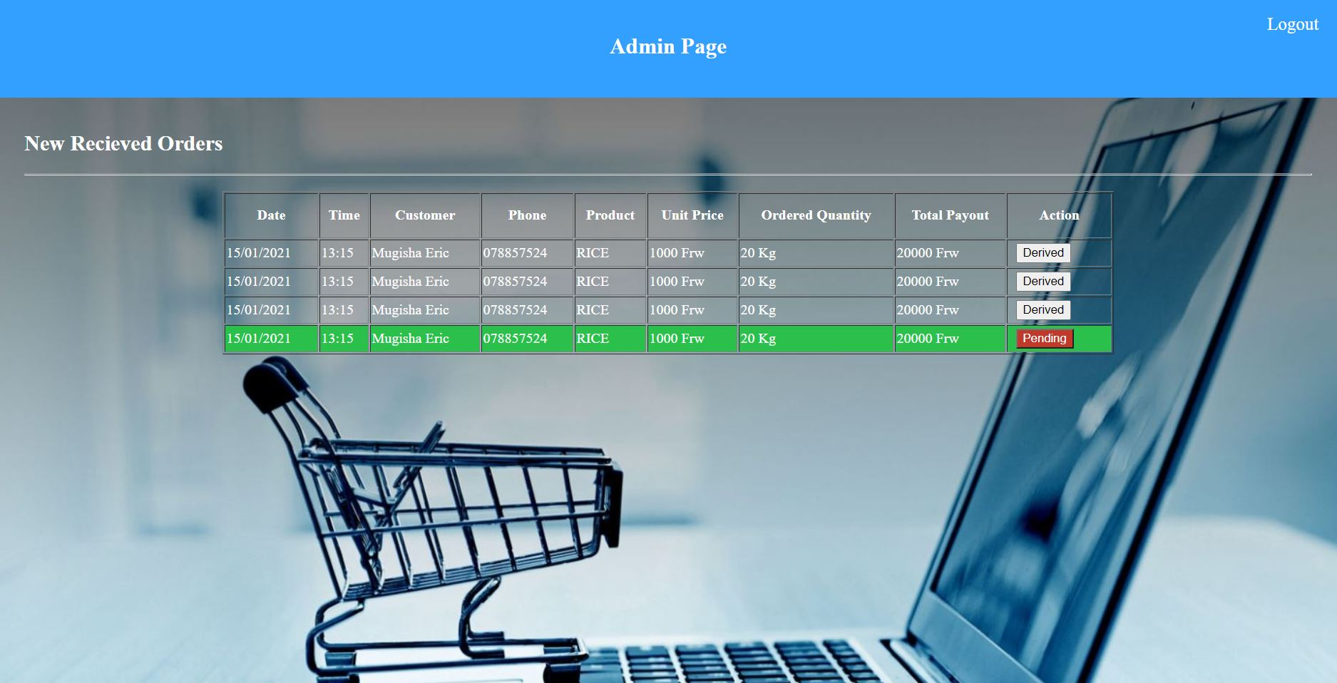

**FIGURE 8**

This is a crucial page for the platform, it shows all the orders we received from the customers, and we also be able to see the status and time.

**RESET PASSWORD PAGE**

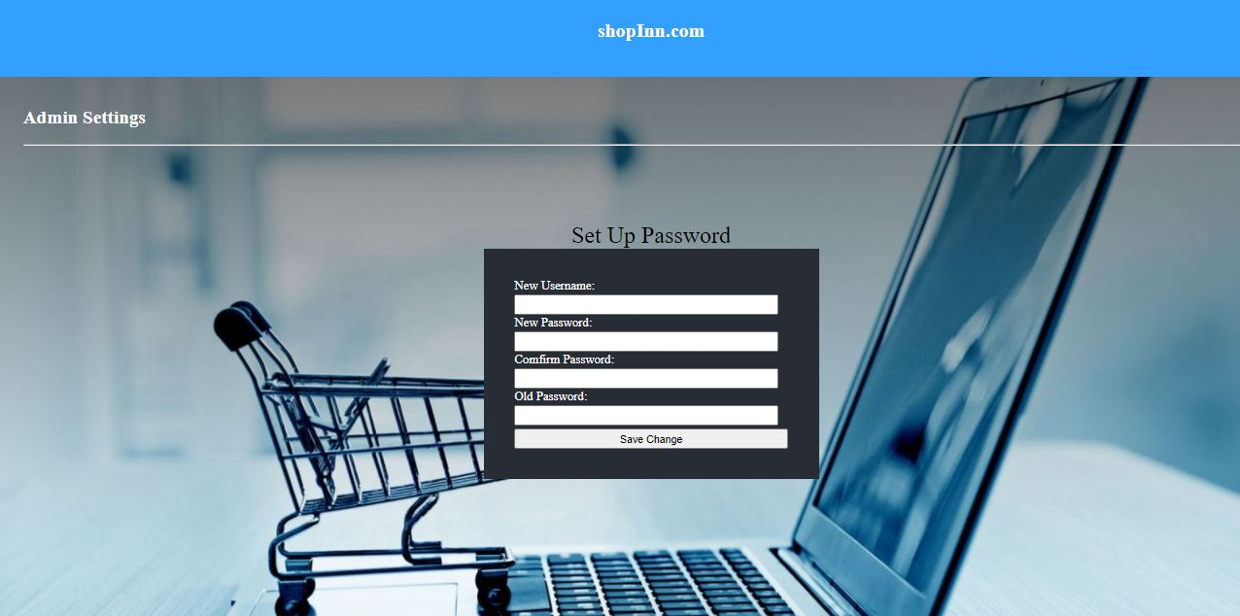

**FIGURE 9**

The reset password this is the page that help you to change the old password to a new password of f your choice, this mainly done for the purpose of security.

**CUSTOMER LIST PAGE**

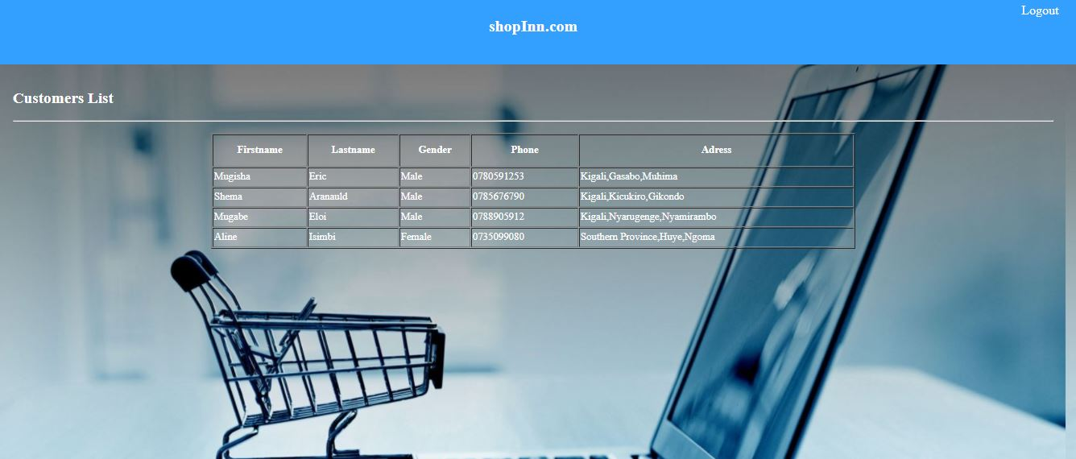

**FIGURE 10**

This is the page for displaying all the customers’ information we have in the database.